May 10, 2016
Math Matter
Working hard and studying new geometric definitions, the students of both 6th and 7th grade regular math have been putting their memorization skills to the test. Geometry requires almost an entirely new vocabulary and these girls are up for the challenge. In order to show what they know, the students created their very own tessellations. Tessellations have been around for centuries and are shapes that fit together like puzzle pieces with no overlaps and no gaps. By integrating mathematics and art, these 14 girls have not only learned a ton of new vocabulary, but likewise have created masterpieces.
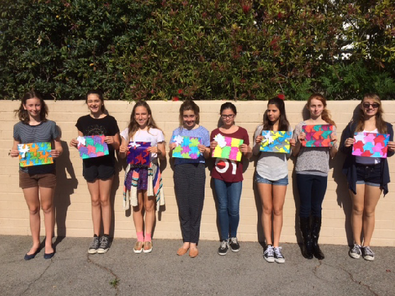

Science and Pepperdine
On Wednesday, May 6th, our seventh grade class traveled to Pepperdine to participate in science experiments under the direction of Professor, Dr. Tom Vandergon. The seventh graders were treated to multiple labs at the Marine Biology Lab at Pepperdine. Both the Drs. Vandergon were there to run the amazing labs. The students learned how to classify marine organisms and read a dichotomous key. They also had the opportunity to hatch grunion, dissect squid, and dissect a crayfish. They conducted themselves like real scientists with these hands-on experiences, and thoroughly enjoyed themselves. Thanks again to the Vandergons for all they contribute to the science program at OLM.
