2018 Queens
- Miss Junior Teen United States
src="https://static1.squarespace.com/static/5b3a46a53c3a533b5326084b/t/5b4def9f88251ba9e4c44054/1531834275958/Jr+Teen.jpg" alt="Rachel Deangelis - 2018 Miss Junior Teen United States" /> 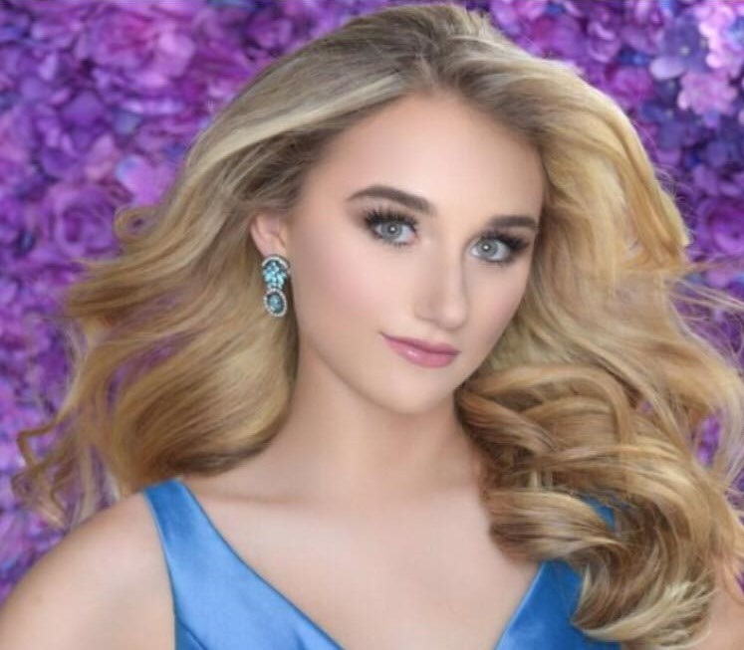
Rachel Deangelis
2018 Miss Junior Teen United States
Rachel is a 10th grade honor student at Laurel Springs High School. As the chairperson of the Health and Wellness Program with the Malibu Youth City Commission, Rachel has volunteered over 600 hours with 50 different organizations: Pacer’s National Bullying Prevention, American Diabetes Association, Best Buddies, Heal The Bay, Malibu Labor Exchange, Relay For Life (Crown With A Cause), Youth Across America, Operations Blanket Of Love, LA River Clean Up, Bullying Prevention Solution Station, Santa Monica Homeless Shelter, No Kids Hungry, Los Angeles School District teaching 5th graders to eat healthy and exercise, Little Dresses for Africa, No Image Malaria and many others.
She has appeared in over 800 modeling publications including Harper’s Baazar, Glamour magazine, LA fashion week, Style Fashion week, CVS, Hilton Hotel and Macys. Also appearing in many TV shows and commercials such as Fresh Off The Boat, Kool-Aid, CVS, L’Oreal and XL-3, just to name a few.
In the past three years of holding several regional titles in California, her most favorite award was receiving the Outstanding Community service award because of her great influence promoting campaign “Healthy Heart Health Life” in collaborations with the American Heart Association. She inspires to help other people how have lost a loved one due to heart disease and partner Governor Jerry Brown making CPR a California requirement.
She was honored to receive two major awards best evening gown designed by Giselle Boone and Kenneth Barlis and runway/National bald eagle costume by Giselle Boone.
Her talents include dancing (Latin Ballroom, Funk, Jazz, Hip Hop and Lyrical) and has appeared on many shows and fashion designing (sketching, draping and sewing women’s apparel) which have been displayed several red-carpet events.
Her future goal is to graduate with a degree in Bio Nutrition and minor in Fashion Design from Washington State University.

